Women cell webinar Report
Women cell in association with Kerala state women Development corporation (KSWDC) was organised an webinar on ‘ Time and stress management’ through google meet on 23/November/ 2021 at 7.00PM. The programme start with welcome speech by Deepthy k ( women cell coordinator). Sahid Payyannur (Psychologist) was the resource person. 55 students were dparticipated in the programme
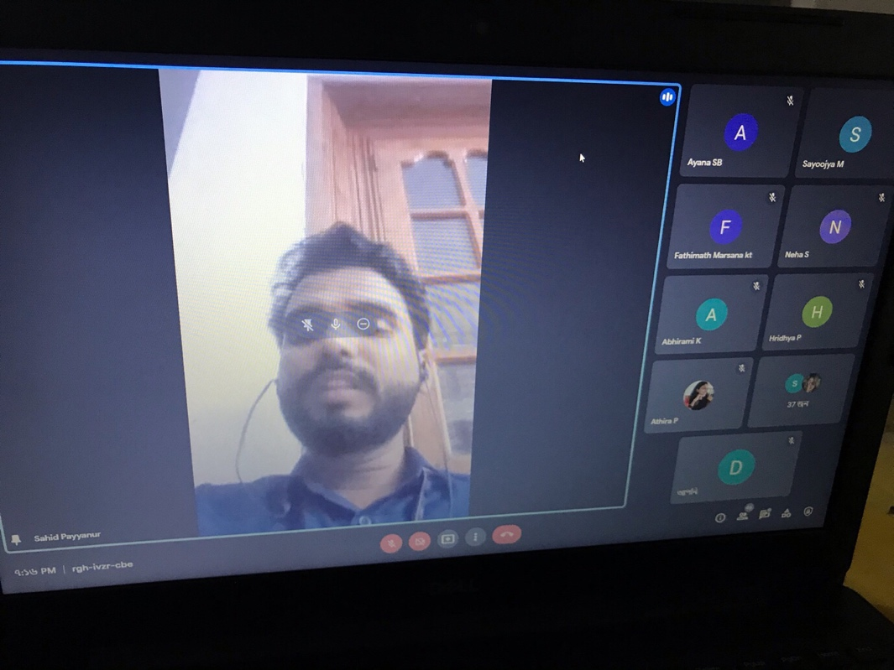
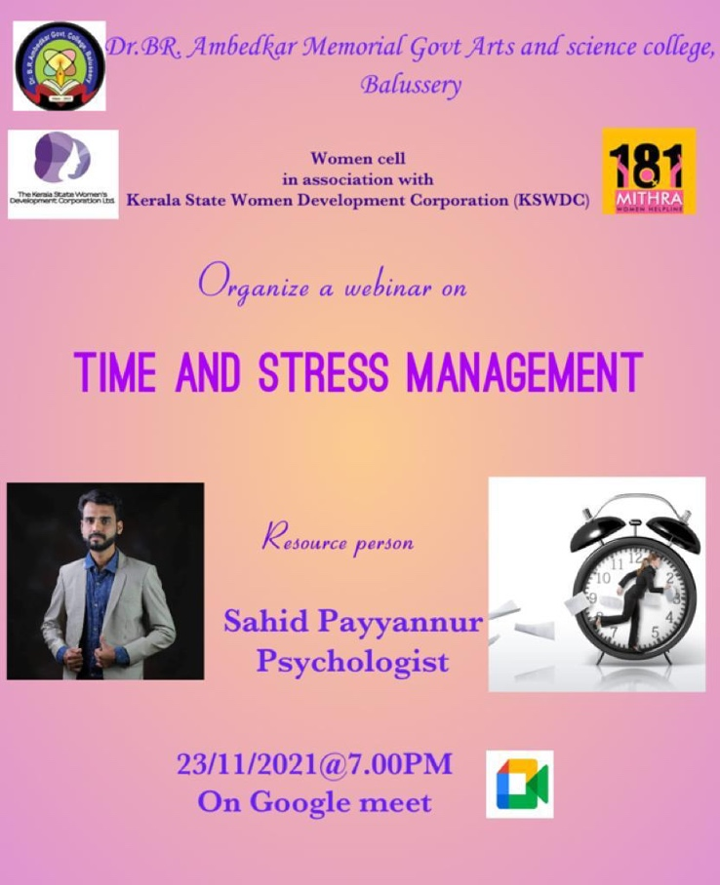

Women cell in association with Kerala state women Development corporation (KSWDC) was organised an webinar on ‘ Positive mental attitude’through google meet on 15/December / 2021 at 7.00PM. The programme start with welcome speech by Deepthy k ( women cell coordinator). Farhan Sayed( consultant Psychologist) was the resource person. 57students were participated in the programme.

